NSW Kendo Association’s Code of Behaviour for Kendo, Iaido and Jodo
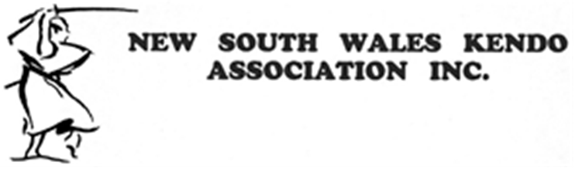
The codes of behaviour that follow identify key principles on which competitors, parents, coaches, administrators, officials and spectators should base their involvement. The codes of behaviour will ensure that we all develop good sporting behaviours and have an enjoyable experience. This will encourage everyone to remain actively involved throughout their lives and show courtesy and respect to each other.

Parents and Spectators
- Focus on the efforts and performance rather than on winning.
- Encourage competitors to always compete according to the rules of the NSWKA and settle disagreements without resorting to hostility or violence
- Do not to ridicule or abuse competitors for making a mistake or losing
- Respect all official decisions, show appreciation for the efforts of volunteers, coaches and administrators
- Respect the rights, dignity, and worth of every person regardless of their background, gender, culture or religion
- Unsportsmanlike language, verbal abuse of officials, insulting other competitors or deliberately distracting or provoking officials are not acceptable or permitted at NSWKA events
- Anyone found abusing or insulting any official or competitor, will be warned and may be asked to leave the event/venue

Competitors
- Respect and abide by the NSWKA event rules and all officials decisions in competition
- Never argue with or openly disagree with any official or shinpan.
- During competition if there is a disagreement the competitor must have their coach or sensei approach the officials directly
- All competitors must learn to control their temper. Verbal abuse of an official and insulting other competitors, deliberately distracting or provoking an opponent are not acceptable or permitted behaviour in NSWKA events
- Respect the rights, dignity and worth of all competitors regardless of their gender, ability, cultural back-ground or religion
- Any competitor found to be abusing the NSWKA code of behaviour can be reprimanded, removed from the current event and/or denied entry into further NSWKA events

Sensei & Coaches
- Clubs which do not exercise control over their players, parents of players, coaches, officials or spectators may be called upon by the NSWKA to accept responsibility for their actions and the following penalties may apply; warning, suspension or expulsion from the NSWKA
- Operate within the rules of NSWKA and the spirit of your art and teach your students to do the same
- Ensure that all training and safety equipment meet the requirements of the NSWKA
- Show concern and caution towards sick and injured competitors. Follow the advice of officials when determining whether an injured competitor should or should not compete any further
- Respect the rights, dignity and worth of every person regardless of gender, ability, cultural back-ground or religion
- Display control, respect and professionalism to all. This includes opponents, coaches, officials, administrators, parents and spectators.

Officials
- At all times officials will respect the rules and regulations set out by the NSWKA event organisers
- Give all competitors a "fair go" regardless of their gender, ability, cultural back-ground or religion
- All officials of NSWKA will be totally non-biased in their rulings and decisions during competition
- Respect the rights of all sensei, coaches and competitors wishing to lodge a protest
- All protests will be bought forward to the relevant NSWKA Technical Committee. All protests will then be heard amicably, fairly and non-biased
- At all times all shinpan and officials regardless of their back-ground will always show courtesy and respect to the competitors, coaches, parents, spectators and each other

Important
Every person who attends a NSWKA event does so with the permission and license of the NSWKA. Breaches of these codes of behaviour may result in penalties up to and including warning, suspension or expulsion from this and future NSWKA events.

